**BUS LOCATOR SYSTEM**

**EXPERIMENT-7**

### Modified Class Diagram for Bus Reservations System:

1. **Bus:**
   * **Attributes:** bus Id, registration Number, route Id, total Seats, available Seats
   * **Methods:** update Available Seats(), get Bus Details()
2. **Driver:**
   * **Attributes:** driver Id, name, phone Number, license Number
   * **Methods:** assign To Bus (bus Id), get Driver Details()
3. **Route:**
   * **Attributes:** route Id, route Name, stops List, start Point, end Point
   * **Methods:** add Stop (stop), remove Stop(stop), get Route Details()
4. **Passenger:**
   * **Attributes:** passenger Id, name, email, phone Number
   * **Methods:** make Reservation (bus Id, seat Number), cancel Reservation (reservation Id), get Reservation Details ()
5. **Bus Stop:**
   * **Attributes:** stop Id, stop Name, location
   * **Methods:** get Buses Arriving (route Id), update Location(new Location)
6. **Reservation:**
   * **Attributes:** reservation Id, bus Id, passenger Id, seat Number, reservation Status
   * **Methods:** confirm Reservation(), cancel Reservation(), get Reservation Details()

### Relationships:

* **Bus** operates on a specific **Route**.
* **Driver** drives a **Bus**.
* **Passenger** makes a **Reservation** on a **Bus**.
* **BusStop** has multiple **Routes** passing through it.
* **Reservation** is associated with a **Passenger** and a **Bus**.

### Object Diagram for Bus Reservations System:

An object diagram will represent specific instances of the above classes and their relationships at a particular point in time.

### Example Illustration:

Let's create a visual mockup of this system, showing the structural view adapted for the bus reservations system.

I'll start with modifying the provided image to reflect these changes.

**Relationships**

- **Bus** operates on a specific **Route**.

- **Driver** drives a **Bus** on a **Route**.

- \*\***Passenger** can track a **Bus** and request it at a **BusStop**.

- **BusStop** has multiple **Routes** passing through it.

- **Real-time** Location Tracking** for buses and bus stops.

### Notes

- Bus: Tracks its current location and is associated with a specific route and driver.

- Driver: Manages the bus and updates its location; associated with a specific bus and route.

- Route: Defines the path buses follow, with designated stops.

- Passenger: Requests buses and tracks their locations.

- BusStop: Has buses arriving and departing, with multiple routes passing through.

This adaptation ensures that the class diagram reflects the entities and relationships relevant to a bus locator system, emphasizing real-time tracking and management of buses, drivers, routes, passengers, and bus stops.

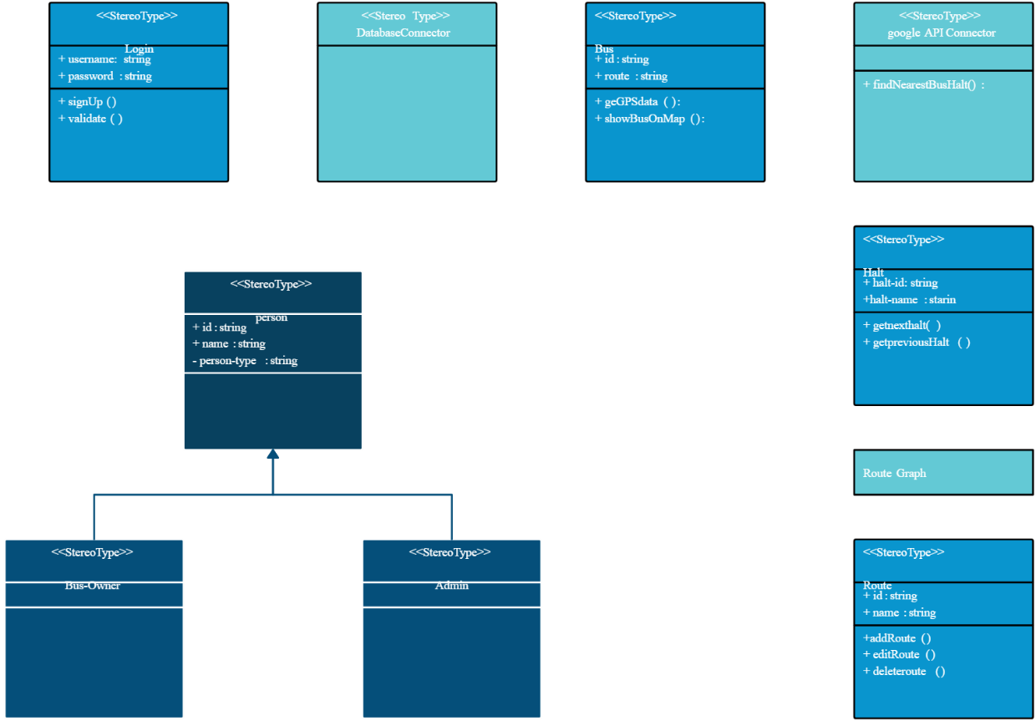

# Object Diagram

An object diagram is a snapshot of the system at a particular point in time, showing instances of the classes and the relationships between them.

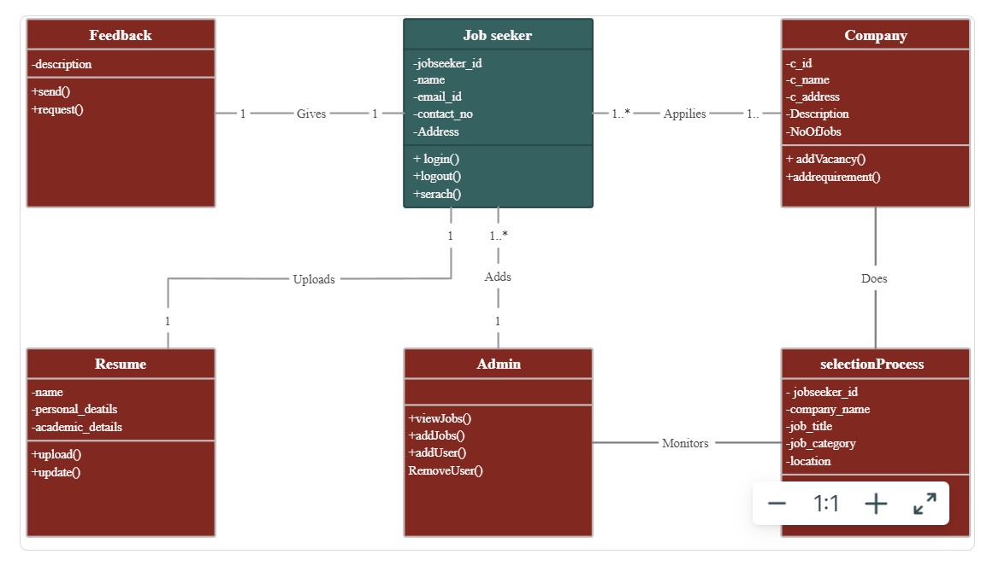

This object diagram represents a specific instance of the classes and their relationships at a given time, providing a clear snapshot of how the bus locator system system functions.